# [**Kelli Giddish Sends Message to SVU Fans Ahead of Final Episode as Rollins**](https://tvline.com/2022/12/08/kelli-giddish-last-law-and-order-svu-episode-season-24-episode-9-rollins/)

By [Michael Ausiello](https://tvline.com/author/michael-ausiello/) / December 8 2022, 4:06 PM PST

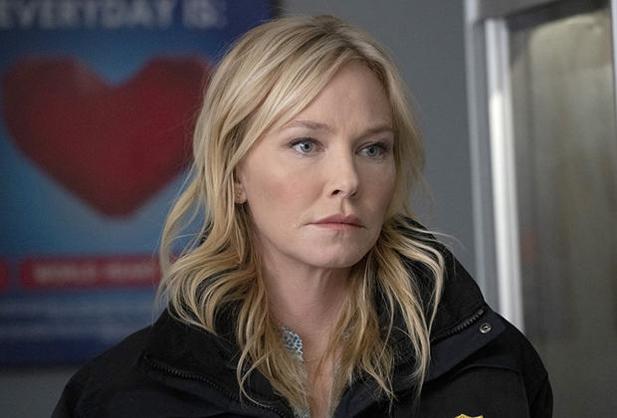

Courtesy of NBC

* [**2**](https://tvline.com/2022/12/08/kelli-giddish-last-law-and-order-svu-episode-season-24-episode-9-rollins/#comments)

Just hours before her final [*Law & Order: SVU*](https://tvline.com/tag/law-and-order-svu/) episode is set to air, [Kelli Giddish](https://tvline.com/tag/kelli-giddish/) is expressing gratitude to Rollins fans far and wide.

[**The 52 Most Shocking Cast Exits Announced in 2022**](https://tvline.com/lists/tv-characters-leaving-2022-shocking-cast-exits/?ref=https://tvline.com/2022/12/08/kelli-giddish-last-law-and-order-svu-episode-season-24-episode-9-rollins/)

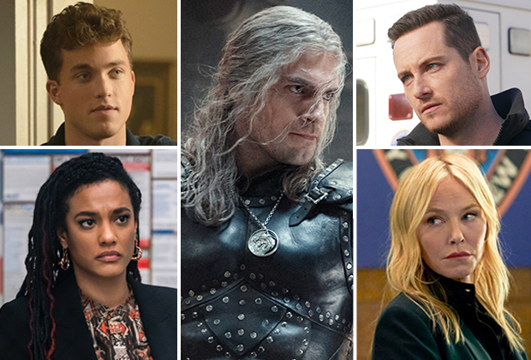

[**Launch List**](https://tvline.com/lists/tv-characters-leaving-2022-shocking-cast-exits/?ref=https://tvline.com/2022/12/08/kelli-giddish-last-law-and-order-svu-episode-season-24-episode-9-rollins/)

“To everyone who supported Rollins – *thank you*,” the actress wrote on [Instagram](https://www.instagram.com/p/Cl7OtfQJ8jL/) Thursday alongside a collection of photos of her and her cast mates, including OG leading lady Mariska Hargitay.

Warren Leight, who served as *SVU*‘s showrunner for years, [offered his own tribute to Giddish](https://twitter.com/warrenleightTV/status/1601016159993663488) in a tweet on Thursday: “When we first started writing for [Kelli Giddish], I wondered if there was anything she couldn’t do. Emotion, exposition, authority, vulnerability, empathy… I soon realized, no matter what we came up with, she’d always make it work, seemingly without effort. It’s been a privilege.”

It was last August that Giddish confirmed that the NBC procedural’s current 24th season would be her last as Det. Amanda Rollins, announcing in a statement, “I wanted to address the chatter I’ve seen online and let everyone know that this will, indeed, be my last season on *Law & Order: SVU.* Playing Rollins has been one of the greatest joys and privileges of my life. I’ve been so fortunate to be a part of the *Law & Order* family for the last 12 years. There is simply no other character on TV like Rollins. She’s grown and changed, and I have as well. I started on this show when I was in my late 20s and I’m grateful I got to spend so many of my adult years with Rollins in my life.”

Amid conflicting reports about the [reason for Giddish’s exit](https://tvline.com/2022/08/24/law-and-order-svu-kelli-giddish-leaving-rollins-season-24/), then-new showrunner [David Graziano](https://tvline.com/tag/david-graziano/) took to Instagram to urge fans to “take a moment to entertain the idea that things are more complex than they appear in a world of emojis and tweets,” adding, “All I’ll say is Kelli has handled this with the most incredibly classy comportment. She is, without a doubt, one of the finest industry professionals I’ve come acrossin my 24 years of writing television. I’m saddened by her looming exit. It’ll be my lucky day if I ever get to write for her again.”

The [promo](https://tvline.com/2022/11/17/law-and-order-svu-rollins-carisi-married-wedding-video-season-24-episode-9/) for tonight’s episode shows Giddish’s Det. Amanda Rollins and Peter Scanavino’s Assistant District Attorney Sonny Carisi preparing to get married at the courthouse. As TVLine previously reported, her character will *not* be killed off during the hour. In fact, Giddish is slated to reprise her role as Rollins on *SVU*‘s sibling series *Law & Order: Organized Crime* later this season.